**Radio Frequency Controlled Bot**

**Introduction:-**

In present time almost all the people are familiar with robots. Robots play a very important role in human life. Robots are a machine which reduces the human efforts in heavy works in industries, building etc. and makes life easy

. 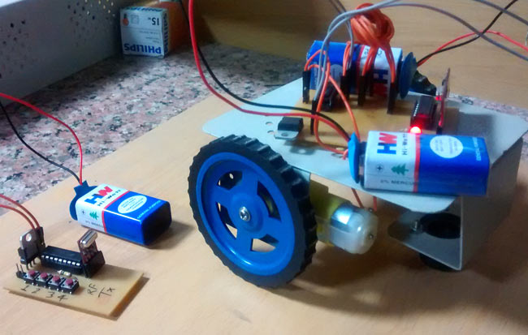

**Problem Statement**

You have to design a very interesting robot, that is **RF controlled Robot**. Interesting thing in this Event is that it will run without using any microcontroller. You have to run it directly by RF Decoder and Motor Driver.

**Rules**

* A Team may consist of atleast 2 members but should not exceed 5
* Extra marks for inter branch team
* The components required for making the circuit will be issued prior to event. No component will be issued during the event.
* Participants are required to present their circuits at the time of event hours**.**

**Specifications**

* Your objective is to design and construct a robot such that the distance between your robot and your own made joystick should be maximum
* Formulate a logic that can use simple electronic devices i.e. encoder (HT12E) and decoder (HT12D) IC in such a way that will trigger the siren generator (UM3561) to generate noise.
* The encoder is used for encoding parallel data for transmission feed while reception is decoded by a decoder.

**Judging Criteria**

* Neatness of the circuit.
* Extra features implemented, may add much to your score. They should complement the original design.
* All basic compulsory features should be implemented and only after their evaluation would the extra features would be considered and assessed.

**Resources**

* **Encoder -** <http://www.engineersgarage.com/electronic-components/ht12e>
* **Decoder-**http://www.engineersgarage.com/electronic-components/ht12d-datasheet
* **Video-** <https://www.youtube.com/watch?v=xl5hj6F_-Sc>

**Contact**

Divyanshu Agrawal

+91-9462245799 [agrawal.2@iitj.ac.in](mailto:agrawal.2@iitj.ac.in)

Chirayu Parashar

+91 7073400151 [parashar.1@iitj.ac.in](mailto:parashar.1@iitj.ac.in)